
Computer Graphics
（ 2025 / 2026 1st Term）

Title ： Implementation of SSAO Using OpenGL

Major | Computer Science and Technology
Name | Md Shoriful Islam Fahim
ID | F23040134
Tutor | Rui Huang
Department | CST
Date | 2025.12.28

Grading | 得分
能够掌握图形学的相关基础知识，并能够针对求解的工程问题，进行合理的分析与设计,从而实现相应的功能。（10）
能够选择合适的程序设计语言与课程提供的代码平台，对问题进行系统设计、实现与验证。（20）
报告内容符合要求，满足研究类报告的基本要素构成。（30）
报告的格式美观，图片、文字、公式、代码设置合理。（15）
能够体现出学习相关算法以及解决报告提出课题的自学能力。（10）
总分（85）
指导教师： 2026 年 1 月 10 日

Implementation of Screen Space Ambient Occlusion (SSAO) Using OpenGL

1、Task and Objectives
This project will focus on the implementation of Screen Space Ambient Occlusion (SSAO), an Advanced Graphics Rendering technique for producing Ambient Light Effects in 3D Scene (Ambient Occlusion is one of the most essential components that sine qua non to achieving the most realistic results possible from Rendering). Ambient Occlusion helps Developers simulate Accurate Ambient Lighting.

There is a large amount of visual information represented in our virtual environments through the use of ambient occlusion. Therefore, it is extremely important to utilize screen-space calculations to achieve fast and effective implementations of this information. With this approach, we will allow Developers to utilize SSAO when Working on Video Games or interactive Visualizations.

The purpose of this project is to provide a thorough understanding of contemporary graphical programming. The first objective is to create a full multi-pass rendering pipeline using the OpenGL 3.3 Core Profile as the foundation for SSAO (Screen Space Ambient Occlusion). The multi-pass rendering pipeline is responsible for rendering all stages of a scene using multiple passes - geometry processing, occlusion calculation, noise filtering, and final lighting blend. The second goal is to develop a strong understanding of the deferred shading method. Deferred shading is accomplished by separating geometry processing from the application of lights; by storing information about geometry into several separate render targets or those referred to as the Geometry Buffer, or "G Buffer". This technique allows for efficient handling of a large number of lighting conditions, while also providing the necessary geometric information to calculate SSAO.

To satisfy the third goal of the project, suitable random sample kernels must be generated from the occlusion testing. These kernels need to be randomly distributed on a hemisphere surrounding each vertex of a surface, with careful attention to how densely packed the samples are throughout the hemisphere in order to balance performance with quality. The fourth goal of the project addresses the use of post-processing techniques to correct for noise artifacts caused by rotating random sample kernels; specifically, blurring techniques were used to reduce the noise caused by rotational movement. This process produces smooth results that do not take away from the overall quality of the scene. The fifth goal of the project focuses on achieving real-time rendering at a minimum frame rate of thirty frames per second on current-day computer hardware at a resolution of 1280 x 720 pixels. Finally, the sixth goal is to demonstrate the results of using this technique on complex three-dimensional (3D) objects such as the Stanford Dragon Model, which contains enough geometrical detail to illustrate how ambient occlusion increases realism and visual depth in a scene. In completing the project's objectives, the end result will serve as an example of applying theoretical concepts learned in computer graphics (e.g., coordinate space transformations, framebuffer management, shader programming, and optimization techniques) in an interactive, real-time rendering environment.

2、Theory and Algorithm
The method used for calculating Ambient Occlusion in computer graphics is based on the fact that Ambient Light is not uniform across all surfaces of an object within a 3D scene. An example of this would be a room where light can pass through the window or door, but due to objects blocking or partially blocking these light sources, the surfaces within the corner of a room will not receive as much ambient light as the exposed wall, floor, and ceiling. Since computer graphics traditionally use a constant Ambient Lighting amount to calculate the total amount of Ambient Light on every surface, this method ignores the subtle changes in Ambient Lighting that influence Depth Perception & Realism. To correct this problem, Ambient Occlusion calculates the Occlusion Factor for each of the visible surfaces. The Occlusion Factor indicates how much Ambient Light is being blocked from that surface by an object in close proximity, or by other surfaces, and is used to create depth perception. The Occlusion Factor is multiplied by the Ambient Light amount applied to that surface to determine the final amount of Ambient Light on the surface. Areas that are in corner areas, have surfaces touching each other (Contact Shadows), and other areas that are 'closed' will all have lower Ambient Light than the remaining surfaces, thereby creating more shadows in these areas and reducing the overall volume of ambient light on the surfaces of an object creating depth perception.
The basis of SSAO is the concept of visibility sampling from all angles on the hemispherical surface surrounding a point on the surface. To determine the ideal ambient occlusion value for a point on the surface, rays would be emitted in all directions inside of the hemisphere aligned with the normal vector (i.e. N), and the number of ray intersections with nearby geometry would be counted. The computational expense of using ray-based techniques for computing ambient occlusion in real-time rendering make them unusable; therefore, an alternative method was developed using Screen Space Ambient Occlusion to create an approximation of ambient occlusion using data contained within the depth buffer in order to calculate an ambient occlusion approximation based on the available geometric data previously generated during the rendering process rather than to calculate true ambient occlusion. In addition, the ambient occlusion approximation is computed using a deferred shading approach in which the required geometric data, including position, normal vectors, and albedo color, are written to multiple render targets throughout the initial geometry rendering pass to form a G-Buffer, which is then used during later passes to perform lighting and post-process operations.
The SSAO mathematical formulation begins by sampling a variety of points within a hemisphere centered around each fragment's position, and then comparing their depth values relative to those in the position buffer. Each fragment at view-space location P (with surface normal N) generates a corresponding set of sample points S located within a sphere of radius r centered at P. Sample points are converted from tangent-space coordinates into view-space coordinates using a tangent-basis-normal (TBN) matrix calculated from the surface normal and a random tangent vector. Sample points' x and y coordinates are converted to screen-space coordinates, then sampled depths from the position buffer are sampled from these coordinates. A sample contributes toward the occlusion factor if the depth retrieved from the position buffer indicates the position sampled is behind the actual geometry. The occlusion factor is computed as the ratio of occluded sample points to all sample points. In general, the computed value is inverted so that 1.0 represents no occlusion, while 0.0 represents complete occlusion.
The main algorithms are listed as follows：
（1）The first algorithm to be discussed is G-Buffer generation based on deferred shading algorithms. The first phase of deferred shading is called the geometry pass. In this phase, we will render each piece of geometry to a different render target (multiple) at one time. In addition, we will transform vertex positions & normals into view space (view space) so we are consistent with perspective projections. The results of screen-space ambient occlusion (SSAO) computations will also be performed in view space for all objects. The fragment shader output will write the position of each vertex in view space into the first render target (color attachment), at RGBA16F precision to preserve floating-point accuracy. View space normal information will be sent to the second render target (color attachment), also using RGBA16F precision, and the surface albedo color will be sent to the third render target, with RGB8 precision. The depth of each pixel will also be written to the framebuffer render buffer, so the depth testing can be done accurately during the geometry pass. All of the information we need for future processing of our geometry can be acquired efficiently during the geometry rendering by using the technique of rendering to multiple render targets.

- The second algorithm implements the core SSAO computation. For each fragment in screen space, the algorithm begins by reading the view-space position and normal from the G-Buffer. A random rotation vector is sampled from a small 4x4 noise texture that is tiled across the screen. This random vector is used to construct the TBN matrix by computing a tangent vector perpendicular to the normal through Gram-Schmidt orthogonalization, then computing the bitangent as the cross product of the normal and tangent. The TBN matrix allows transformation of sample points from a fixed hemisphere in tangent space to a hemisphere oriented according to the surface normal in view space. For each of the 64 sample points in the kernel, the algorithm transforms the sample to view space using the TBN matrix, adds it to the fragment position scaled by the sampling radius, and projects the resulting position to screen space. The algorithm then samples the position buffer at the projected screen coordinates to retrieve the stored depth value. If this stored depth is greater than or equal to the sample depth plus a small bias value, the sample is considered occluded. A range check is applied using a smooth step function to prevent samples that are too far from the fragment from contributing to occlusion, which helps reduce artifacts at object boundaries. The accumulated occlusion values are averaged and inverted to produce the final occlusion factor, where values close to 1.0 indicate no occlusion and values close to 0.0 indicate high occlusion.

- A spatial filtering algorithm is used for noise reduction in the third algorithm. The SSAO output is seen to contain clear visible noise patterns (due to rotating the sample kernel randomly) that can be smoothed before rendering the final image. Therefore a blur pass is performed on the SSAO output; a blur algorithm will sample a 4x4 neighbourhood of pixels around each pixel and create an average occlusion value of the surrounding occlusions. This box blur diminishes the noise while allowing for the retention of the basic occlusion structure. More complex implementations may want to employ a bilateral filter to keep edges crisp; however, this implementation employs a simple box blur, which is adequate and does not impact real-time speed. The resulting blur occlusion values will be written into a second framebuffer, to be used in the final lighting stage.

- The fourth algorithm achieves its final visual composition through lighting composition. To obtain lighting, this algorithm reads the entire contents of the G-Buffer (which stores all the related information on positions/normals/albedo's) per fragment together with the blurred SSAO values. To calculate lighting, the algorithm utilizes the Blinn-Phong reflection model to compute ambient, diffuse and specular components. One of the key areas where SSAO is integrated into the lighting calculations is modifying the ambient light term by multiplying by the occlusion factor, causing areas of occlusion to have a lower ambient contribution. Each fragment still receives the diffuse and specular contributions from all light sources (both point and directional), and since ambient occlusion only affects indirect ambient light, the correct amounts of diffuse and specular light from these sources are still added to the overall final colour. Therefore, the final colour is calculated from the ambient component (after it has been multiplied by the occlusion factor), the diffuse component and the specular component, and then each of these three components is multiplied by the albedo associated with the surface to obtain the total final rendered image. The final rendered images appear to have realistic ambient occlusion and provide a greater sense of depth in terms of visual quality.

3、Implementation
3.1 Algorithm Design and Implementation
The software was developed using the C++ programming language with OpenGL3.3 core profile for graphics rendering. Development included many other supporting libraries such as GLFW for creating windows and processing user input from multiple platforms, GLEW for loading OpenGL extensions and GLM for mathematical operations (i.e., performing mathematical operations with vectors and matrices) as well as Soil2 for loading textures from image files. The development of the software took place using XCode on macOS. This development environment also requires the use of certain forward compatibility flags for OpenGL due to specific implementation constraints imposed by macOS on OpenGL. The software renders images at a resolution of 1280x720 pixels, which strikes a compromise between visual quality and computational efficiency for real-time interaction.

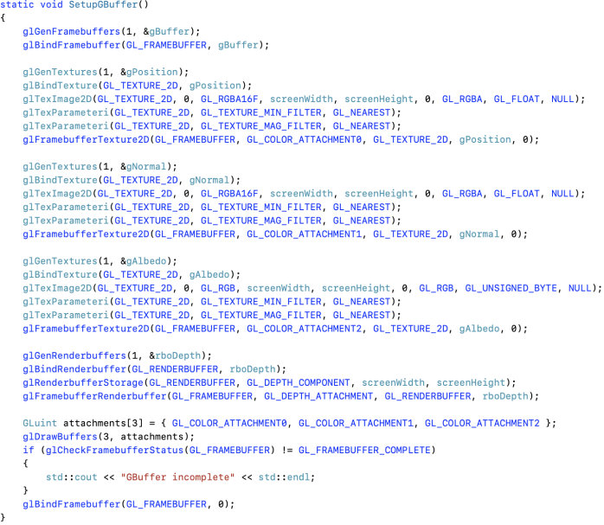
3.1.1 G-Buffer Setup Implementation
The G-Buffer configuration represents the foundation of the deferred shading pipeline. As shown in Figure 3.1, the SetupGBuffer function creates a framebuffer object with three color attachments and one depth renderbuffer. The position attachment utilizes RGBA16F format to store view-space positions as floating-point values, ensuring sufficient precision for depth comparisons during SSAO computation. The normal attachment also uses RGBA16F format to store view-space normals with high precision, as small errors in normal values can significantly affect lighting calculations. The albedo attachment uses RGB8 format to store base color information, which requires less precision than geometric data. The implementation calls glGenFramebuffers to create the framebuffer object, then binds it and attaches three textures using glFramebufferTexture2D with color attachment points GL_COLOR_ATTACHMENT0, GL_COLOR_ATTACHMENT1, and GL_COLOR_ATTACHMENT2. The depth renderbuffer is created with glGenRenderbuffers and attached using glFramebufferRenderbuffer with GL_DEPTH_ATTACHMENT. Finally, glDrawBuffers is called with an array specifying all three color attachments to enable simultaneous rendering to multiple targets.
Figure 3.1: SetupBuffer function
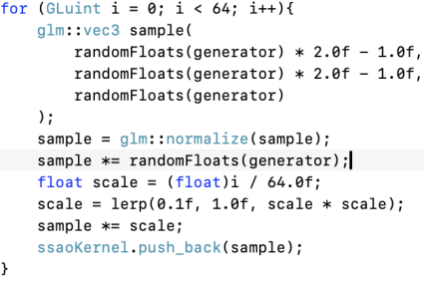
3.1.2 SSAO Kernel Generation Implementation
The SSAO sample kernel generation occurs during initialization before the main rendering loop begins. As shown in Figure 3.2, the SetupSSAO function generates 64 sample points distributed within a unit hemisphere. The implementation uses a lambda function to define the lerp interpolation helper, then creates random number generators using std::uniform_real_distribution and std::default_random_engine from the C++ standard library. For each of the 64 samples, three random floating-point values are generated, with x and y components ranging from negative one to positive one, and the z component ranging from zero to one to ensure samples fall within the positive hemisphere. The random vector is normalized and multiplied by another random scalar to distribute samples throughout the hemisphere volume. The key optimization involves applying an accelerating interpolation function computed as lerp(0.1, 1.0, scale × scale) where scale equals the sample index divided by 64. This quadratic function concentrates early samples near the origin while distributing later samples further outward, providing better occlusion detection for fine geometric details.
Figure 3.2: 64 sample points generate loop
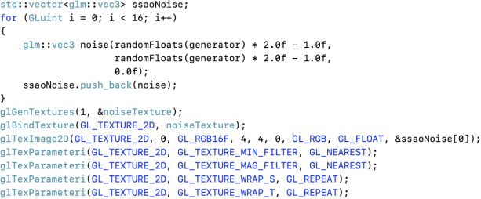
As shown in Figure 3.3, the noise texture generation creates a 4x4 texture containing random tangent-space vectors. The implementation generates 16 random vectors with x and y components ranging from negative one to positive one, while z components are set to zero to ensure vectors lie in the tangent plane. These vectors are uploaded to a texture with GL_RGB16F internal format using glTexImage2D, and the texture parameters are configured with GL_NEAREST filtering and GL_REPEAT wrapping to enable seamless tiling across the screen.
Figure 3.3: Noise texture
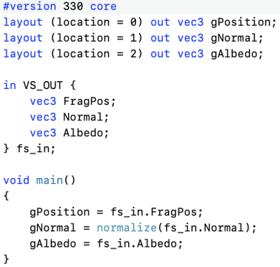
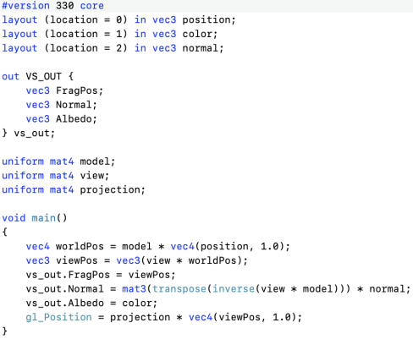
3.1.3 Geometry Pass Shader Implementation
The geometry pass shaders transform scene geometry to view space and output geometric data to the G-Buffer. As shown in Figure 3.4, the vertex shader ssao_geometry.vs transforms vertex positions and normals from model space to view space using the model-view matrix, then passes these values along with the albedo color to the fragment shader. The fragment shader, as shown in Figure 3.5, receives the interpolated values and writes them to three separate output locations corresponding to the G-Buffer attachments. The position is written to the first output as a vec4 with w component set to 1.0, the normal is written to the second output, and the albedo color is written to the third output.
Figure 3.5: Fragment shader
Figure 3.4: Vertex shader

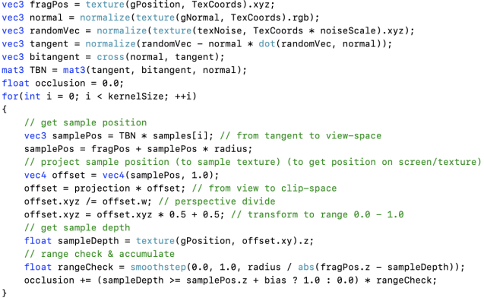
3.1.4 SSAO Computation Shader Implementation
The SSAO computation represents the core algorithm of this implementation. As shown in Figure 3.6, the ssao.fs fragment shader implements the hemisphere sampling approach. The shader begins by sampling the position and normal textures from the G-Buffer, then samples the noise texture at scaled coordinates computed as texture coordinates multiplied by the noise scale vector. The TBN matrix construction uses Gram-Schmidt orthogonalization to compute a tangent vector perpendicular to the normal, then computes the bitangent as the cross product of normal and tangent. The main sampling loop iterates over all 64 kernel samples, transforming each from tangent space to view space using the TBN matrix, adding the scaled offset to the fragment position, and projecting to screen space using the projection matrix. For each sample, the shader retrieves the stored depth value from the position buffer and performs the depth comparison with bias and range checking. The accumulated occlusion values are averaged and inverted to produce the final occlusion factor.
Figure 3.6: ssao.fs hemisphere sampling approach

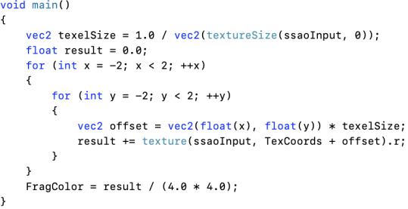
3.1.5 Blur Pass Implementation
The blur pass smooths the noisy SSAO output through spatial filtering. As shown in Figure 3.7, the ssao_blur.fs shader implements a simple box blur that samples a 4x4 neighborhood around each pixel. The shader calculates texture coordinate offsets based on the inverse screen dimensions, samples the SSAO texture at each offset position, accumulates the values, and divides by 16 to compute the average. This effectively removes high-frequency noise while preserving the overall occlusion structure.
Figure 3.7: ssao_blur.fs implements a sample box blur
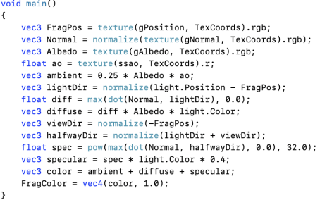
3.1.6 Final Lighting Pass Implementation
The lighting pass combines all previously computed data to produce the final rendered image. As shown in Figure 3.8, the ssao_lighting.fs shader reads position, normal, and albedo from the G-Buffer, along with the blurred SSAO value. The shader implements Blinn-Phong lighting with ambient, diffuse, and specular components. The critical modification for SSAO integration involves multiplying the ambient lighting term by the occlusion factor, which darkens ambient contribution in occluded areas while leaving direct lighting components unaffected. The final color is computed as the sum of the modulated ambient term, the diffuse term based on Lambert's cosine law, and the specular term using the Blinn-Phong half-vector approach.
Figure 3.8: ssao_lighting.fs main function

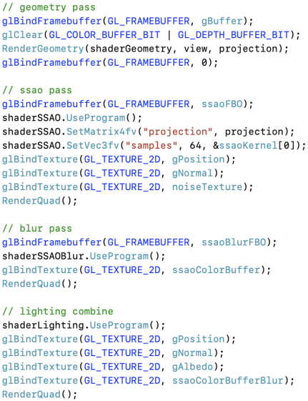
3.1.7 Main Rendering Loop Implementation
The main rendering loop orchestrates the four-pass rendering pipeline. As shown in Figure 3.9, the main function in main.cpp executes the passes sequentially within the while loop. The geometry pass binds the G-Buffer framebuffer and calls RenderGeometry to draw the scene. The SSAO pass binds the SSAO framebuffer, configures the SSAO shader with projection matrix and sample array, binds the position, normal, and noise textures, and renders a full-screen quad. The blur pass binds the blur framebuffer, configures the blur shader, binds the raw SSAO texture, and renders another quad. Finally, the lighting pass renders to the default framebuffer, configuring the lighting shader with light parameters and binding all required textures including the blurred SSAO result. The implementation calls glfwSwapBuffers to present the final image and glfwPollEvents to process user input.
Figure 3.9: main function all passes

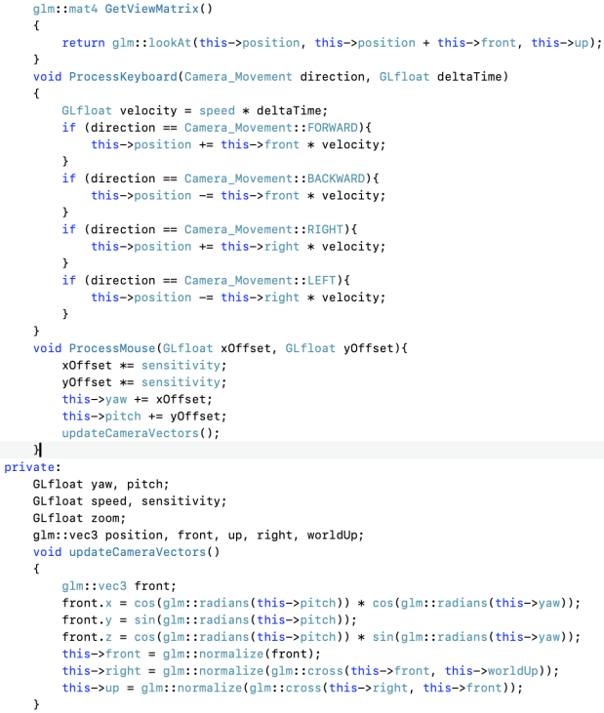
3.1.8 Camera Control Implementation
The camera system enables interactive scene exploration through keyboard and mouse input. As shown in Figure 3.10, the Camera class maintains position, orientation vectors, and movement parameters. The ProcessKeyboard method updates camera position based on movement direction and delta time, moving forward, backward, left, or right relative to the view direction. The ProcessMouse method updates yaw and pitch angles based on cursor displacement, with sensitivity scaling to control rotation speed. The ProcessScroll method adjusts the zoom field of view based on scroll wheel input. The GetViewMatrix method constructs the view transformation using GLM's lookAt function with camera position, target position, and up vector.
Figure 3.10: camera.h key functions

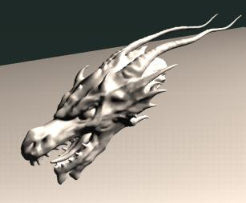
4、Results
The hardware and software environment for this implementation consists of a modern macOS system with an Intel or Apple Silicon processor and graphics processing unit supporting OpenGL 3.3 or higher. The development environment utilizes Xcode as the integrated development environment, with C++ as the programming language and OpenGL 3.3 Core Profile as the graphics API. The implementation successfully achieves real-time rendering performance, maintaining frame rates exceeding 60 frames per second at the target resolution of 1280 pixels width by 720 pixels height.
Figure 4.1: Final output
The visual results demonstrate significant enhancement in depth perception and realism compared to traditional ambient lighting. As shown in Figure 4.1, the final rendered scene displays the Stanford Dragon model positioned on a floor plane with realistic ambient occlusion darkening areas where the dragon's geometry creates crevices and corners. The contact shadows where the dragon meets the floor appear naturally darkened, enhancing the perception that the model is grounded on the surface rather than floating. Fine geometric details in the dragon model, particularly in areas with complex surface curvature, exhibit enhanced depth through subtle shading variations that follow the surface topology.
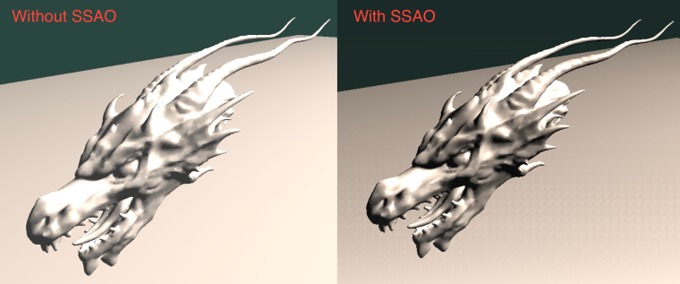
As shown in Figure 4.2, the comparison between the scene rendered with SSAO enabled versus SSAO disabled clearly demonstrates the visual improvement provided by ambient occlusion. The version without SSAO appears flat and lacks depth, with uniform ambient lighting failing to capture the geometric complexity of the model. The version with SSAO shows proper darkening in occluded regions, creating a more three-dimensional appearance and better visual separation between the model and the floor plane. The lighting appears more natural and believable, with proper balance between illuminated and shadowed regions that match human expectations of how ambient light behaves in real environments.
Figure 4.2: Comparison between SSAO and without SSAO
Performance profiling reveals that the SSAO computation pass represents the most expensive stage, consuming approximately 40 percent of frame time due to the 64 samples per pixel and multiple texture lookups required for each sample. Despite the multi-pass architecture and substantial per-pixel computation, the overall performance remains well within real-time requirements at over 60 frames per second, validating the efficiency of the screen-space approach for interactive applications.

5、Some Issues and How to
Issue 1: Incorrect G-Buffer Texture Formats
During initial implementation, the position and normal buffers were configured with RGB8 format, which stores color values as 8-bit unsigned integers. This format proved insufficient for storing geometric data requiring signed values and higher precision. View-space positions with negative coordinates and the limited 8-bit precision caused severe quantization artifacts in the SSAO computation, resulting in noisy output with visible banding patterns due to incorrect depth comparisons.
How to:
The solution involved changing the texture formats to RGBA16F, which stores four components as 16-bit floating-point values. The texture creation code was modified to specify GL_RGBA16F as the internal format parameter in the glTexImage2D function call. This change eliminated the quantization artifacts and enabled accurate depth comparisons, producing clean SSAO output with sufficient precision for geometric calculations.

Issue 2: Surface Acne and Self-Occlusion Artifacts
Surface acne occurs when a surface incorrectly occludes itself due to floating-point precision limitations. When sample points are generated very close to the surface, depth comparisons may incorrectly determine occlusion, causing a speckled appearance on flat surfaces. This artifact was particularly visible on the floor plane where random dark speckles appeared despite the absence of nearby occluding geometry.
How to:
The solution introduced a bias parameter of 0.025 units in view space that offsets the depth comparison threshold, preventing false positive occlusion detections from floating-point imprecision. Additionally, a range check using a smooth step function attenuates sample contributions based on depth distance, preventing distant samples from incorrectly contributing to occlusion. This approach eliminates surface acne while minimizing light leaking and reducing halo artifacts at object silhouettes.

6、Conclusion
This project successfully implemented Screen Space Ambient Occlusion using OpenGL, demonstrating comprehensive understanding of advanced real-time rendering techniques including deferred shading, multi-pass rendering, and post-processing effects. The implementation achieves all specified objectives, maintaining real-time performance exceeding 60 frames per second at 1280 by 720 resolution while processing complex geometry. The visual results demonstrate significant enhancement in depth perception and realism compared to traditional ambient lighting, with natural darkening of occluded areas such as corners, crevices, and contact shadows.

The project provided valuable learning experiences in several critical areas of computer graphics programming. Understanding deferred shading architecture revealed the benefits of separating geometry processing from lighting calculations, enabling efficient complex post-processing effects. The implementation of framebuffer objects and multiple render targets demonstrated proper management of graphics resources and data flow between rendering passes. The SSAO algorithm illustrated important concepts in sampling theory, including the trade-offs between sample count, distribution strategies, and filtering techniques in balancing quality and performance. The project encountered and overcame several technical challenges including selecting appropriate texture formats for geometric data storage, developing effective sample distribution strategies, and addressing surface acne through bias parameters.

While SSAO represents a significant improvement over naive ambient lighting, it has inherent limitations as a screen-space technique. The method can only consider geometry visible in the current view, meaning that off-screen objects do not contribute to occlusion. Despite these limitations, SSAO remains widely adopted in real-time applications due to its favorable performance characteristics and generally convincing results. Future enhancements could include implementing temporal filtering to reduce noise across frames, bilateral blur filtering to better preserve edges, and hierarchical depth buffer approaches to accelerate sample depth testing. The completed implementation serves as a solid foundation for exploring more advanced rendering techniques and demonstrates that achieving realistic, high-quality real-time graphics requires theoretical understanding, practical implementation skills, careful optimization, and systematic debugging.

